State Fair Community College

Residence Hall
Fire Safety Report
2025

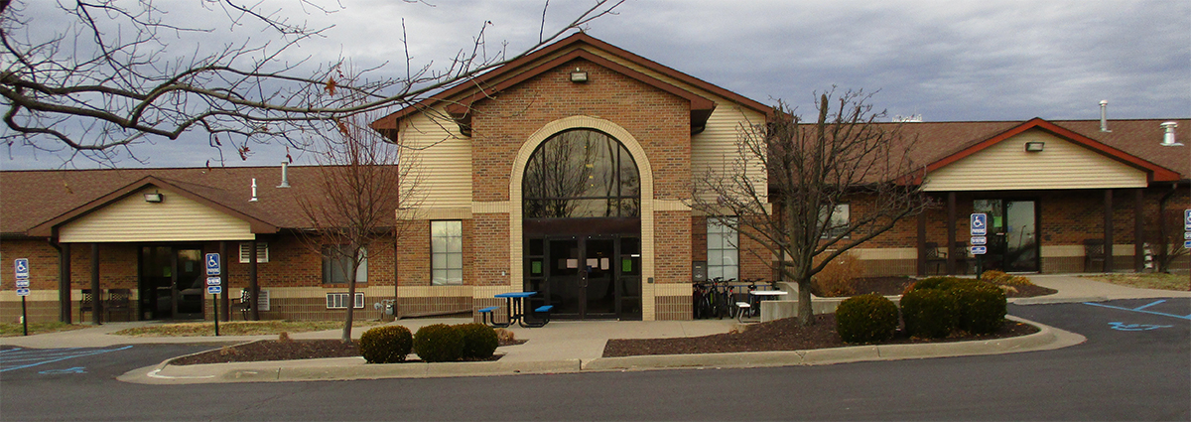

Prepared by:

State Fair Community College
3201 W. 16th Street
Sedalia, MO 65301

September 30th, 2026

According to the Higher Education Opportunity Act (HEOA) a school that participates in a Title IV program and has on-campus housing facilities must annually publish a fire safety report that contains information with respect to campus fire safety practices and standards of the school. This report is updated annually and made available for review on the State Fair Community College website. Notification of the report is made electronically to all students and employees via mySFCC announcements on or before October 1.

- The number of fires and the cause of each: 1 – 3/18/25 3:45 AM Student was using an air fryer in the North Café in the Residence Hall, food caught on fire. Student closed the drawer of the air fryer to extinguish the flame. No damage to property or injuries.
- The number of fire related injuries that result in treatment at a medical facility: 0
- The number of fire related deaths: 0
- The value of property damage caused by a fire: 0

- The fire safety/sprinkler system is a “dry system” that houses pipes above each room to be activated by heat. If a fire is present, the pipes will activate and fill with water. The room will then be watered from above. Anytime the system loses water pressure the alarm will sound. This system is checked annually.

- The residence hall safety system consists of smoke detectors in each room and common area. When activated the fire alarm system will sound and each hallway door will automatically shut, but not lock. Each hallway has a fire exit that will also sound an alarm if opened. Each hallway has two exits. Also, each room has windows that can easily be used for evacuation.

- The residence hall holds regular fire drills at least twice each semester. During all planned and unplanned fire drills, students are required to evacuate the Residence Hall. During all fire drills, students in the Residence Hall are to adhere to the following procedures:

  - Exit the facility as quickly as possible, leaving doors unlocked.
  - Report to the designated area (basketball goal on the south end of the parking lot).
  - Pull the fire alarm when exiting the building. If the fire alarm has already been activated, contact 9-1-1 and notify Residence Hall Assistant(s).
  - Do not re-enter the Residence Hall until authorized College personnel have determined it is safe to do so.

- The following are not allowed in the residence hall:
  - Explosives or Explosive materials (including flammable liquid: gasoline, lamp oil, etc.)
  - Fireworks
  - Appliances with open elements (flame or electric)
  - George Foreman Grills or similar devices
  - Candles of any kind or incense

- The Residence Hall also has the following regulations concerning safety equipment:
  - Smoke Detectors: The smoke detectors in the residence hall are extremely sensitive and can be set off by curling irons, burnt food, etc. Accidentally setting off the smoke detectors is common but residents should be aware of the panic that can set in by a false alarm.
  - Fire Alarms: Tampering with safety equipment or repeatedly triggering the fire alarm, particularly in the same fashion, is a gross violation of SFCC’s community principles.
  - Tampering with safety equipment or cameras: The security cameras, fire extinguishers, and other safety equipment are there for the safety and wellbeing of the residents tampering of this equipment is not tolerated.

- The Office of Residence Life does not recommend any additions or improvements to the current fire safety system.

- The following table represents the fire drills, including evacuation, of the Residence Hall during 2025. The Director of Student Life is responsible for planning and executing fire drills. An ongoing log of planned and unplanned fire drills can be reviewed upon request in the Office of Student Life.

Fire Drills:
02/18/25
03/31/25
10/6/25
11/20/25

Accidental Smoke Detector Activation:
1/19/25

3/7/25

3/28/25

10/2/25

Actual Fires:

3/18/25

